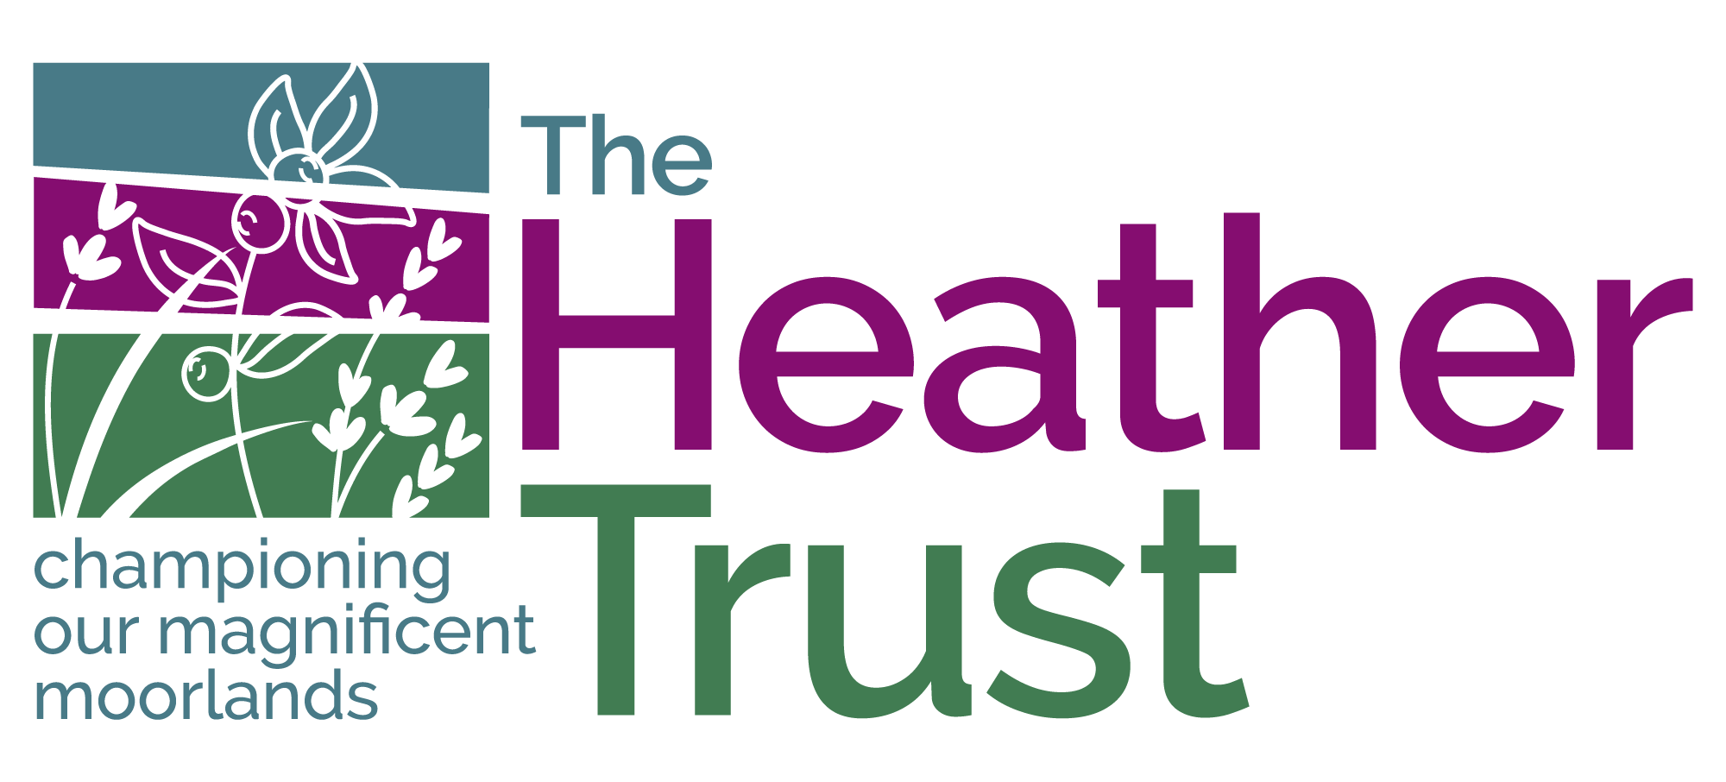


Press Release
FOR IMMEDIATE RELEASE – 12.11.24
Landscape management and community preparation is key to mitigating wildfire here in the UK
THE COMMON thread of preparing landscapes and communities for the threat of wildfire ran through day one of the UK Wildfire Conference – Resilience in a Changing World in Aberdeen today (12 November).
Almost 250 delegates gathered at Wildfire2024 at P&J Live to hear from global experts who shared their experiences of wildfire across a range of landscapes in South Africa, Chile, Norway, Portugal, Canada and others. The collective message was one of using wildfire prevention techniques that reduce damage and create wildfire resilient communities by adopting traditional and new techniques to manage landscapes, in tandem with responsive policy frameworks.
The conference opened with an address by Jim Fairlie MSP, Minister for Agriculture and Connectivity who recognised that wildfires can have a significant impact on our wildlife and environment as well as the economic and social costs to the communities affected by outbreaks of such a destructive force in our countryside.
He said we needed to reduce the preventable wildfires that not only occur here in Scotland but throughout the developed world. In recognising the predicted extension of the wildfire season due to climate change, Mr Fairlie said that we could experience more sustained severe fire danger throughout the year.
He noted the valuable work that event hosts, the Scottish Wildfire Forum carries out and its role in enhancing the partnership work with Scottish Fire and Rescue Service and those with an interest in land management throughout Scotland.
Keynote speaker, Val Charlton of Landworks South Africa said:
“Events like the UK Wildfire Conference are so important because it gives the community of practice, exposure to new ideas, progress and other people’s perspectives.
“Knowledge sharing is key for three reasons; firstly, it is important for the UK community to know that their challenges are not much different from the rest of the world; secondly it is clear that no single nation can win the battle again wildfires on their own - international cooperation is becoming increasingly important; and thirdly, the UK can avoid making the same mistakes – you can learn from others in terms of what works and what doesn’t.
“Globally, we should be placing much more emphasis upon reducing risk at landscape level and involving the people that live in those landscapes and in the natural/urban interface areas. We must make that paradigm shift from suppression focus to prevention focus.
“These challenges are global, but the UK has a fantastic opportunity to avoid repeating the same mistakes as other countries, if it places an emphasis on effective landscape and community planning, backed up with political support and good policies.”
Michael Bruce, Vice Chair of the Scottish Wildfire Forum said:
“We have been treated today to a global perspective of wildfire by some of the leading lights in the sector. Tomorrow, we look forward to an equally rich programme of speakers who will be focussing on where we are in terms of wildfire risk and mitigation in the UK. We will also be discussing controlled burning and its role in building resilience into our landscapes.”
ENDS
Caption:
- Val Charlton, Landworks South Africa was one of the keynote speakers on Day One of the UK Wildfire Conference.
- Today’s conference was preceded by a site visit to the James Hutton Institute Glensaugh Farm, Fettercairn, where delegates saw demonstrations of wildfire fighting equipment including a demonstration by PDG Helicopters.

For more information, contact:
Katrina Candy – katrina.candy@heathertrust.co.uk; tel: 07776 857222

